Stream Restoration Project Completed
The Wyoming County Soil & Water Conservation District, U.S Fish & Wildlife Service and New York State Department of Environmental Conservation Region 9 Bureau of Fisheries have collaborated in the completion of a stream channel restoration project on the Wiscoy Creek in the Town of Pike. This project involved restoring the Wiscoy Creek to its original channel after the stream had changed its course into a former overflow channel and caused severe damage to adjacent cropland.
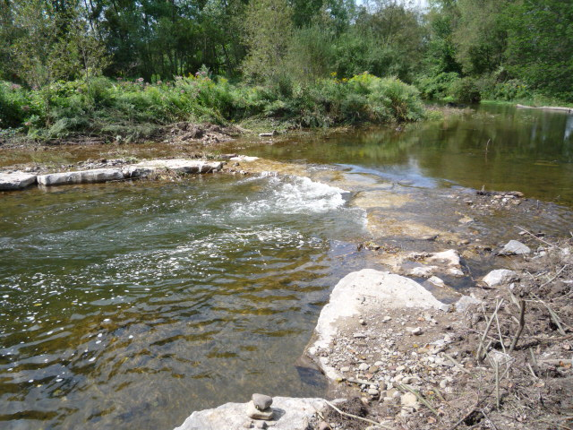
Rock grade control structure completed on the Wiscoy Creek.

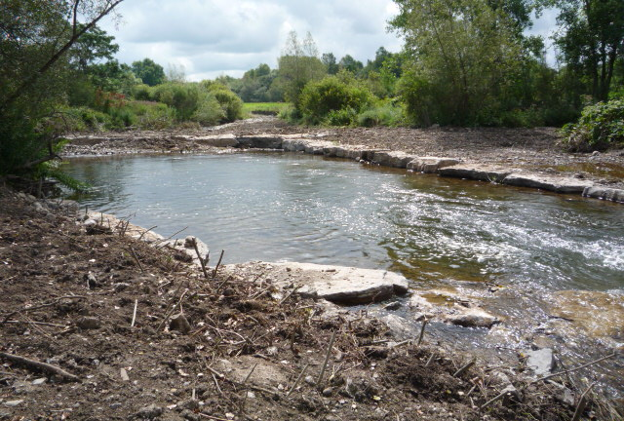
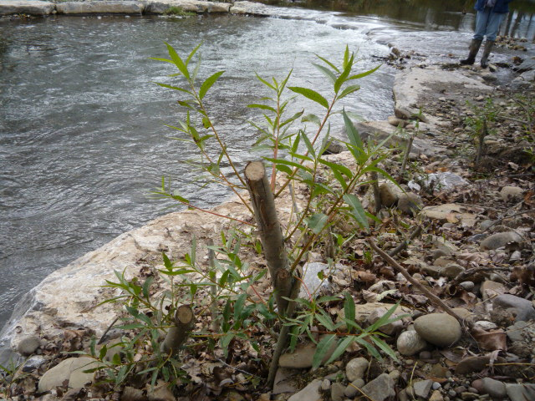

Rock rip-rap channel block to divert stream flow back to its original channel.

Special Thanks to:
Van Slyke’s Dairy Farm, LLC
Springdale Farm
Thomas Ayers
Town of Pike Highway Department
Wyoming County Highway Department
Rock grade control structure completed on the Wiscoy Creek.
WNY Chapter of Trout Unlimited
Rock grade control structure completed on the Wiscoy Creek.
U.S. Fish & Wildlife Service
NYSDEC Region 9 Bureau of Fisheries
NYSDOT
FL/LOWPA
Rock grade control structure completed on the Wiscoy Creek.

